Working of the analytical module

**“Popular List” Window**

As soon as the “Manager Window” button is clicked, the manager is taken into the analytical module of our boba shop management portal. The default window is the unpopulated “popular list” window;

Here the manager can easily see the best-selling drinks or toppings from all our shops, as well as their historical sales count. Once we select the “toppings” option from the drop-down menu, we see the top-selling toppings; Once we select the “drink” option from the drop-down menu, we see the top-selling drinks. The column widths and names are adjusted accordingly.

**“Income” Window**

The “income” window aims to provide a visual representation of the income of our boba shops over a selected time period. The manager can choose a time period based on the data we have collected, and choose to group the income by day, by week, or by month. Note that once the manager selects a date from the “From” drop-down menu, the “To” drop-down menu will change accordingly so only future dates will show up.

For any selected time period, the app will be capable of creating visualizations of summarized income by day, week, and month, as well as adjusting the x-ticks, title, and y-axis labels accordingly.

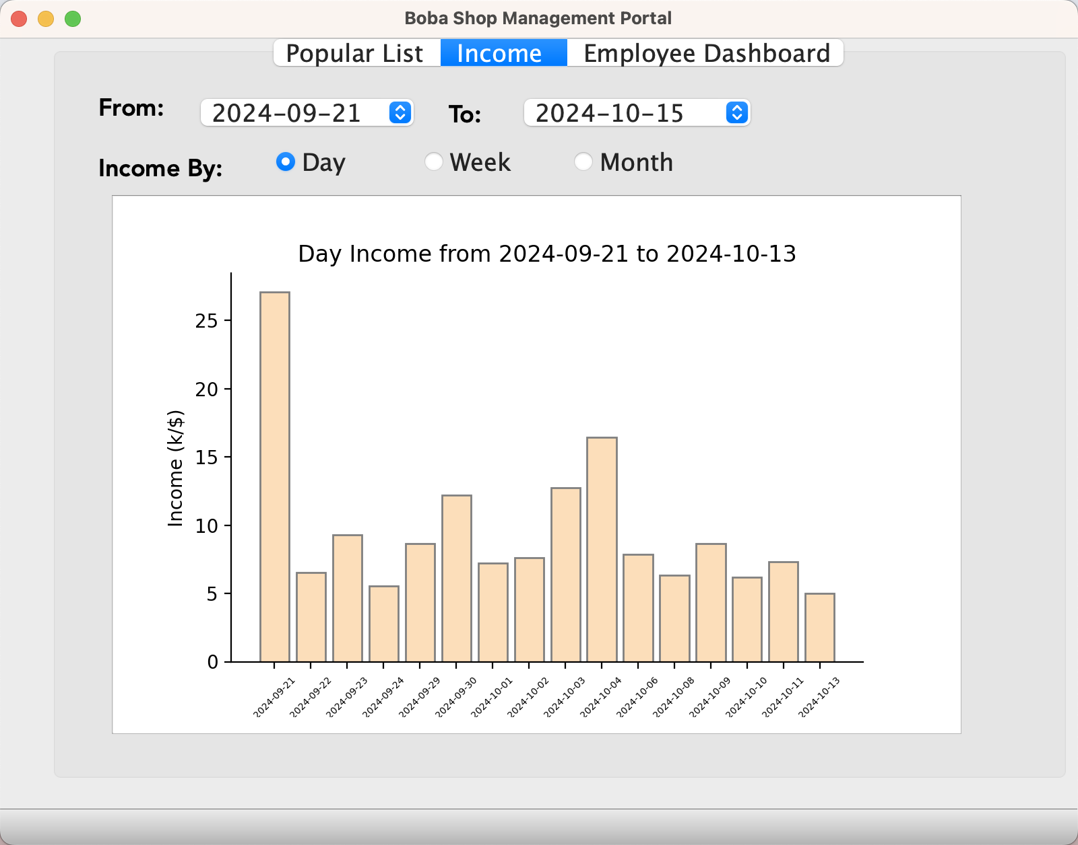

**“Employee Dashboard” Window**

This window aims to provide the manager some basic information of each employee, including their name, phone number, home address, date of birth, employee ID, and the store ID where they work at. In addition, there is also a dashboard on the employee’s vehicle information, including vehicle make, model, year, and plate number.

The manager can see all the current employees from the drop down menu, and selecting an employee from the menu automatically populates the dashboard with employee information.